**PORTFOLIO OF EVIDENCE**

**A Mpitula**

**37460366**

*Architect*

Data Science and Analytics

Data science and analytics include extracting insights from information utilizing statistical analysis, machine learning, and information visualization. Key roles include data scientists, who build predictive models, and data analysts, who interpret data for decision-making. Essential skills encompass programming (Python, R), statistical analysis, and tools like SQL and Tableau. Applications span various industries, including business, healthcare, finance, and retail, driving informed decision-making and strategic planning.

Most proficient in:

C#; HTML & CSS; PYTHON; JAVA

Table of contents

1 MODERATION PREPARATION 1

1.1 Introduction 1

1.2 Pre-CMPG323 Skillset 1

1.2.1 Expectations for CMPG323 2

1.2.2 Ambitions for CMPG323 2

1.3 Career Path 2

2 Training & Certifications 1

2.1 Agile & Scrum 1

2.2 Source Control 1

2.3 Web API 2

2.4 Design Patterns & Standards 3

2.5 UiPath 4

2.6 Data Visualisation 5

2.7 Other 6

3 Project Results 1

4 Project Retrospectives 2

5 Community Engagement 3

5.1 Contributing to a Community or Forum 3

5.2 Extracting Knowledge from a Community or Forum 3

6 Class Attendance 4

7 Class Participation 4

# MODERATION PREPARATION

## Introduction

As part of the preparation for this module, a form was provided to allow students an opportunity to provide details about themselves. Based on the responses received, the following basic information details were captured:

|  |  |
| --- | --- |
| Student Number | 37460366 |
| Initials & Surname | A Mpitula |
| Preferred Name | Alone |
| Preferred Email Address | Alonemapitlula@gmail.com |
| Date of Birth | 2002-01-13 |
| Campus & Delivery Method | Vaal - Contact |
| LinkedIn Profile | https://www.linkedin.com/in/alone-mpitula-3524a3319 |
| GitHub Profile | https://github.com/Mpitula |
| Stack Overflow Profile | https://stackoverflow.com/users/26492851/alone-mpitula |

Table 1‑1: Basic Student Information

## Pre-CMPG323 Skillset

Prior to the commencement of work, students were prompted to provide their current rating of specific skill sets which would be focused on and enhanced throughout the semester. Each skill has been rated as follows:

|  |  |
| --- | --- |
| **Skill** | **Rating** |
| Agile & Scrum Implementation | 3 |
| API Development | 2 |
| Design & Architectural Patterns Implementation | 1 |
| Testing Approach Implementation | 1 |
| Robotic Process Automation Implementation | 1 |
| Data Visualisation Implementation | 2 |

Table 1‑2: Skills Rating

The above table is subject to the following rating descriptions:

1. No prior knowledge/experience with implementation
2. Some knowledge but no experience with implementation
3. Some knowledge and experience with implementation
4. Advanced knowledge and experience with implementation

### Expectations for CMPG323

Module expectations, students to analyse and address business challenges NWU Tech Patterns face, particularly in measuring the benefits and esteem realized from their automation. Students will need to propose arrangements that distinguish time and cost savings for projects and clients, develop secure and dependable front-end applications, and guarantee data is processed and stored safely. The solutions should be both cloud-hosted or on-premises, thoroughly tested, source-controlled, and compliant with industry measures and best practices.

### Ambitions for CMPG323

Throughout the module, I want to acquire technical skills in developing Web APIs, and web applications, and executing Robotic Process Automation (RPA) for testing and learn to create reporting tools for data visualization. Additionally, project management skills through planning, documenting implementations and iteratively delivering and illustrating project progress.

## Career Path

A number of questions were posed to students to prompt their investigation into different professions to decide which they would like to pursue. The following responses were captured for each question:

|  |  |
| --- | --- |
| **Career Options** | **Response** |
| Entrepreneurship | Start a tech startup focused on AI solutions |
| Non-IT Role | Business Consultant or an estate agent |
| Application for Roles | Apply for software developer positions at tech companies. |
| Desired Job Role | Requirement Analysis, Work with stakeholders to understand and gather data. Translate business needs into technical specifications. |
| Desired Company & Profession | Microsoft, Software Engineer |

Table 1‑3: Career Ambitions

# Training & Certifications

## Agile & Scrum

The following achievements were obtained in this category:

|  |  |  |  |  |
| --- | --- | --- | --- | --- |
| **Achievement** | **Type** | **Provider** | **Date** | **Reflection** |
| Click or tap here to enter text. | Click or tap here to enter text. | Click or tap here to enter text. | Click or tap here to enter text. | Click or tap here to enter text. |

## Source Control

The following achievements were obtained in this category:

|  |  |  |  |  |
| --- | --- | --- | --- | --- |
| **Achievement** | **Type** | **Provider** | **Date** | **Reflection** |
| Click or tap here to enter text. | Click or tap here to enter text. | Click or tap here to enter text. | Click or tap here to enter text. | Click or tap here to enter text. |

## Web API

The following achievements were obtained in this category:

|  |  |  |  |  |
| --- | --- | --- | --- | --- |
| **Achievement** | **Type** | **Provider** | **Date** | **Reflection** |
| Click or tap here to enter text. | Click or tap here to enter text. | Click or tap here to enter text. | Click or tap here to enter text. | Click or tap here to enter text. |

## Design Patterns & Standards

The following achievements were obtained in this category:

|  |  |  |  |  |
| --- | --- | --- | --- | --- |
| **Achievement** | **Type** | **Provider** | **Date** | **Reflection** |
| Click or tap here to enter text. | Click or tap here to enter text. | Click or tap here to enter text. | Click or tap here to enter text. | Click or tap here to enter text. |

## UiPath

The following achievements were obtained in this category:

|  |  |  |  |  |
| --- | --- | --- | --- | --- |
| **Achievement** | **Type** | **Provider** | **Date** | **Reflection** |
| Click or tap here to enter text. | Click or tap here to enter text. | Click or tap here to enter text. | Click or tap here to enter text. | Click or tap here to enter text. |

## Data Visualisation

The following achievements were obtained in this category:

|  |  |  |  |  |
| --- | --- | --- | --- | --- |
| **Achievement** | **Type** | **Provider** | **Date** | **Reflection** |
| Click or tap here to enter text. | Click or tap here to enter text. | Click or tap here to enter text. | Click or tap here to enter text. | Click or tap here to enter text. |

## Other

The following achievements were obtained in this category:

|  |  |  |  |  |
| --- | --- | --- | --- | --- |
| **Achievement** | **Type** | **Provider** | **Date** | **Reflection** |
| Click or tap here to enter text. | Click or tap here to enter text. | Click or tap here to enter text. | Click or tap here to enter text. | Click or tap here to enter text. |

# Project Results

The students were equipped with project briefs for five projects that aimed to guide them through the end-to-end journey of the development lifecycle – from planning to reporting. Each project was assessed individually, according to specific criteria and the results of each project are captured below:

|  |  |  |
| --- | --- | --- |
| **Project** | **Result** | **Rubric** |
| Project 1: Agile | P1 % | P1 Rubric Link |
| Project 2: Web API | P2 % | P2 Rubric Link |
| Project 3: Patterns & Standards | P3 % | P3 Rubric Link |
| Project 4: RPA & Testing | P4 % | P4 Rubric Link |
| Project 5: Reporting & Monitoring | P5 % | P5 Rubric Link |

Table 3‑1: Project Results

Based on the performance detailed above, the student has a participation mark of <part mark>. The participation mark for CMPG323 is subject to the following calculation as part of the module mark:

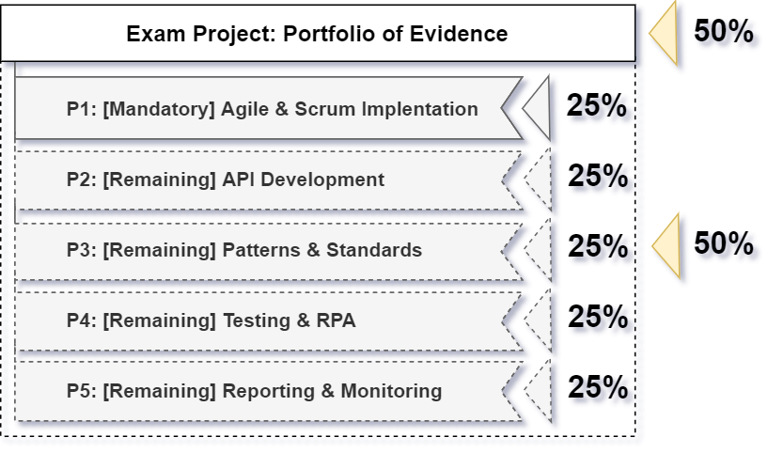

Figure 3‑1: Module Mark Calculation

# Project Retrospectives

Students are encouraged to reflect on every project to determine what went well and should be carried over to the next project, what did not go well and should be focused on to ensure success on the next project as well as what needs to be improved on the next project. The following retrospective items were captured for each project:

|  |  |  |  |
| --- | --- | --- | --- |
| **Project** | **What went well?** | **What did not go well?** | **What needs to be improved?** |
| Project 1: Agile | Click or tap here to enter text. | Click or tap here to enter text. | Click or tap here to enter text. |
| Project 2: Web API | Click or tap here to enter text. | Click or tap here to enter text. | Click or tap here to enter text. |
| Project 3: Patterns & Standards | Click or tap here to enter text. | Click or tap here to enter text. | Click or tap here to enter text. |
| Project 4: RPA & Testing | Click or tap here to enter text. | Click or tap here to enter text. | Click or tap here to enter text. |
| Project 5: Reporting & Monitoring | Click or tap here to enter text. | Click or tap here to enter text. | Click or tap here to enter text. |

Table 4‑1: Project Retrospectives

# Community Engagement

Students are encouraged to use the development communities around them to extract value from as well as produce value back into. Student contribution and engagement can be measured through multiple forms which require evidence of participation and engagement.

## Contributing to a Community or Forum

The student has executed the following tasks as a contribution to a community or forum:

|  |  |  |
| --- | --- | --- |
| **Platform** | **Date** | **Reflection** |
| Click or tap here to enter text. | Click or tap here to enter text. | Click or tap here to enter text. |

## Extracting Knowledge from a Community or Forum

The student has executed the following tasks as an extraction of knowledge from a community or forum:

|  |  |  |
| --- | --- | --- |
| **Platform** | **Date** | **Reflection** |
| Click or tap here to enter text. | Click or tap here to enter text. | Click or tap here to enter text. |

# Class Attendance

Students are urged to make every effort to attend the virtual classes held every Thursday morning to ensure that they get the value and are able to utilise the opportunity to ask questions when they do not understand the work. The following attendance has been captured:

|  |  |
| --- | --- |
| **Class** | **Attendance** |
| 18 July 2024 | Attended |
| 25 July 2024 | Absent |

Table 6‑1: Class Attendance

# Class Participation

Students are urged to make every effort to attend and engage in the virtual classes held every Thursday morning to ensure that they get the value from the class and are able to utilise the opportunity to ask questions when they do not understand the work. The following engagement has been captured as per the completion of class quizzes:

|  |  |
| --- | --- |
| **Activity** | **Completion** |
| Click or tap here to enter text. | Click or tap here to enter text. |

Table 7‑1: Class Participation